# **IBM CLOUD ACCOUNT**

# **PROJECT NAME : WEB PHISHING DETECTION** Team ID : *PNT2022TMID34399*

**TEAM LEADER**

**NAME : ISWARYA A**

**REG NO : 960519205301**

**BRANCH : INFORMATION TECHNOLOGY**

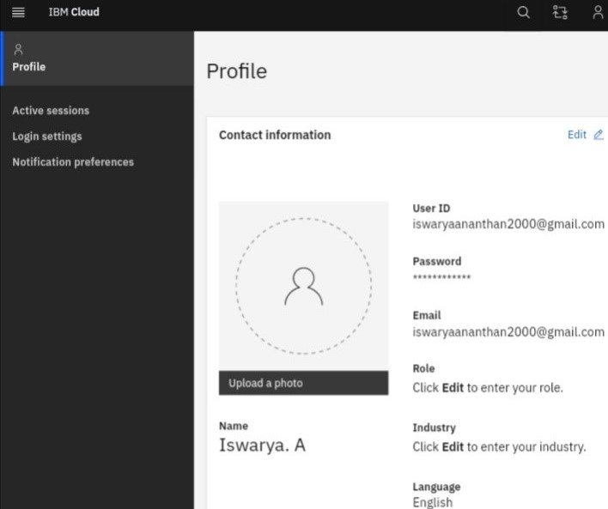

**TEAM MEMBER 1**

**NAME : T.PARVATHY**

**REG NO : 960519205011**

**BRANCH : INFORMATION TECHNOLOGY**

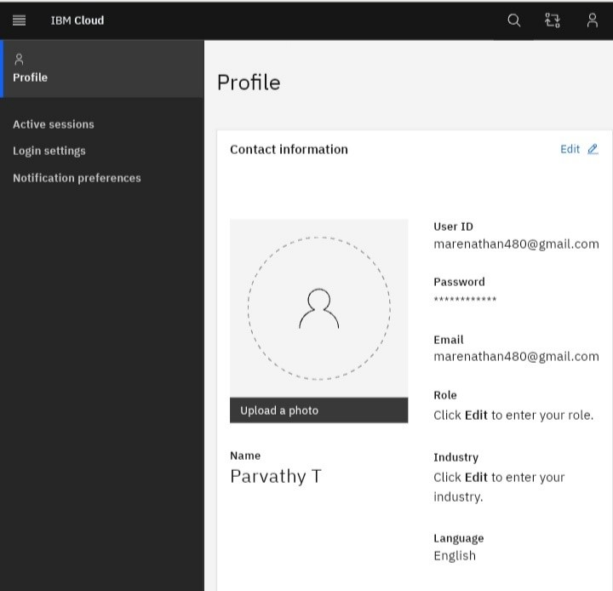

**TEAM MEMBER 2**

**NAME : T.SALINI**

**REG NO : 960519205014**

**BRANCH : INFORMATION TECHNOLOGY**

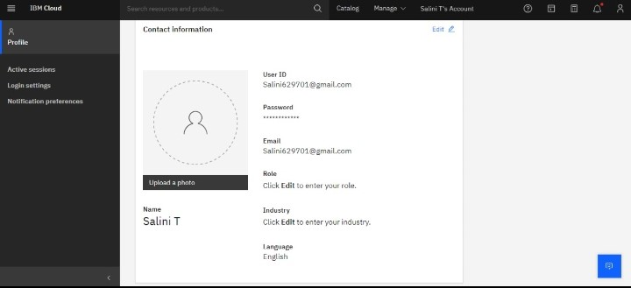

**TEAM MEMBER 3**

**NAME : A.SAHAYA ABISHA**

**REG NO : 960519205501**

**BRANCH : INFORMATION TECHNOLOGY**

